**MECHANIC FINDER WEB APP**

**By**

**GROUP BSE22-20**

**DEPARTMENT OF INFORMATION TECHNOLOGY**

**SCHOOL OF COMPUTING AND INFORMATICS TECHNOLOGY**

**A Software Requirements Specification Report Submitted to the School of Computing and Informatics Technology for the Study Leading to a Project in Partial Fulfillment of the Requirements for the Award of the Degree of Bachelor of**

**Sciences in Software Engineering Of Makerere University**

**Supervisor**

**DR. RASHIDAH KASAULI**

**Department of Information Technology**

**School of Computing and Informatics Technology, Makerere University** [**rashidahk@gmail.com**](mailto:rashidahk@gmail.com)

BY

**GROUP BSE 22-20**

|  |  |  |
| --- | --- | --- |
| **NAME** | **REGISTRATION NO** | **STUDENT NO** |
| **RACKARA ANDERSON** | **18/U/23386/EVE** | **1800723386** |
| **SSEBALAMU RONALD GGAANYA** | **18/U/23401/EVE** | **1800723401** |
| **SSEKKAKA MAHAD** | **18/U/23442/EVE** | **1800723442** |
| **AMANYIRE RAYMOND** | **18/U/23443/EVE** | **1800723443** |

**Software Requirements Specification**

**Table of Contents**

1. Introduction 4

1.1 Purpose 4

1.2 Scope 4

1.3 Definitions, Acronyms, and Abbreviations 5

1.4 References 5

1.5 Overview 6

2. Overall Description 6

2.1 Product Perspective 6

2.2 Product Functions 7

2.3 Operations 7

2.4 User Characteristics 7

2.5 Constraints 8

2.5.1 Platform: 8

2.5.2 Operating system: 8

2.5.3 Hardware: 8

3. SPECIFIC REQUIREMENTS 8

3.1 Functional Requirements 8

3.1.1 FR01: Mechanic Registration 8

3.1.2 FR02: User Registration 9

3.1.3 FR03: Login 9

3.1.4 FR04: Post Vehicle Issue 9

3.1.5 FR05: Search Mechanic Profile & Services 10

3.1.6 FR06: Mechanic Profile 10

3.1.7 FR07: Customer Profile 10

3.1.8 FR08: Mechanic Review and Rating 10

3.1.9 FR09: Edit Profile 10

3.1.10 FR10: Availability Status 10

3.1.11 FR11: Deactivate Account 10

3.1.12 FR13: Mechanic Booking 11

3.1.13 FR14: Chat Box 11

3.1.14 FR15: Report a Complaint 11

3.1.15 FR16: Manage Service Rates 11

3.1.16 FR17: Search Post Vehicle Issue 11

3.1.17 FR18: Warning & Blocking 11

3.1.18 FR19: Logout 11

3.2 Non-Functional Requirements 12

3.2.1 NFR01: Correctness 12

3.2.2 NFR02: Efficiency 12

3.2.3 NFR03: Usability 12

3.2.4 NFR04: Dependability 12

3.2.5 NFR05: Reliability 12

3.2.6 NFR06: Portability 12

3.2.7 NFR07: Data Integrity 12

3.2.8 NFR08: Performance 12

3.2.9 NFR09: Flexibility 13

3.3 Requirement Traceability Matrix 13

3.4 Use Case Description 15

3.4.1 2.5.1 Registration 15

3.4.2 Login 16

3.4.3 Search Mechanic 17

3.4.4 Book Mechanic 17

3.4.5 Mechanic Review and Rating 19

3.4.6 Chat Box 20

3.4.7 Edit Profile 21

3.4.8 Post Vehicle Issue 22

3.5 Use Cases Design 23

3.5.1 Registration 23

3.5.2 Login 24

3.5.3 Search Mechanic 25

3.5.4 Book Mechanic 26

3.5.5 Mechanic Review and Rating 27

3.5.6 Chat Box 28

3.5.7 Post Vehicle Issue 29

3.5.8 Edit Profile 30

3.6 Design Constraints 30

3.6.1 Standards Compliance 30

3.6.2 Hardware limitations 30

3.7 Logical database requirements 30

3.7.1 File Format 30

4. Change management process 32

5. Document Approval 34

6. Supporting Information 34

6.1 Outline of Section 3.1 34

Software Requirements Specification

# Introduction

The introduction of the Software Requirements Specification (SRS) provides an overview of the entire SRS with purpose, scope, definitions, acronyms, abbreviations, references and overview of the SRS.

The purpose of this document is to define the Software Requirement Specifications (SRS) that explain the informational, functional, behavioural and operational aspects of a Mechanic Finder App(MFA) system.

The SRS describes in detail the design of a Mechanic Finder Application system that is augmented through Machine Learning models to automate the process by which the Car drivers can locate the nearest mechanic all over the entire country, thus reduce the amount of time taken for one to locate mechanics of different specialty incase ones car breaks down. It also serves as a basis and helps to create system design, system verification and validation procedures.

## Purpose

The purpose of the document is to collect and analyze all assorted ideas that have come up to define the system, its requirements with respect to consumers. Also, we shall predict and sort out how we hope this product will be used in order to gain a better understanding of the project, outline concepts that may be developed later, and document ideas that are being considered, but may be discarded as the product develops.

In short, the purpose of this SRS document is to provide a detailed overview of our software product, its parameters and goals. This document describes the project's target audience and its user interface, hardware and software requirements. It defines how our client, team and audience see the product and its functionality. Nonetheless, it helps any designer and developer to assist in software delivery lifecycle (SDLC) processes.

## Scope

Primarily, the scope pertains to the MFA features for making easy for drivers to locate nearby mechanics incase of breakdown. It focuses on the drivers(clients), the mechanics(repair service providers) and applications, which provide interfaces through which users can easily find nearby mechanics..

This SRS is also aimed at specifying requirements of software to be developed but it can also be applied to assist in the selection of in-house and commercial software products. The standard can be used to create software requirements specifications directly or can be used as a model for defining a organization or project specific standard. It does not identify any specific method, nomenclature or tool for preparing an SRS.

## Definitions, Acronyms, and Abbreviations

**MFA** – Mechanic Finder App, the software that this SRS describes, simulating a real life conversation and allowing users to choose when to interrupt the given conversation

**SRS** – Systems Requirements Software, this document which outlines the requirements that the software must fulfill. Entirely design independent.

**User** – any person who uses the program, with the general case being car owners with a car problem and mechanics who offer services and availability.

**Administrator** – a person who has administrative access to the advanced settings

**GUI** – graphical user interface

**Login Page** – the initial menu to allow users to register/login

**Home Page** – the initial menu for users who have logged in

**Registration Page** – the page that allows the user to create new accounts

**Login Page** – the page that allows the user to login if they have a valid login

**OS** – operating system

## References

[1] “Home - MechanicUstaad.pk WaqtBachao – Mechanic GharBulao!” MechanicUstaad.pk, [www.mechanicustaad.pk/](http://www.mechanicustaad.pk/).

[2] Shop, Mechanic. “We Give You Car.” AUTOBOYZ, [www.autoboyz.com.pk/](http://www.autoboyz.com.pk/).

[3] “Our Process.” CARiger, [www.cariger.com/](http://www.cariger.com/).

[4] “Car Maintenance Made Easy For You Call MOTOFIX for Your Car Repair at Your Doorstep.” Moto Fix, [www.motofix.pk/](http://www.motofix.pk/).

[5] International Journal of Scientific and Research Publications, Volume 4, Issue 3, March 2014 3 ISSN 2250-3153http://www.ijsrp.org/research-paper-0314/ijsrp-p27119.pdf

[6] STAR_CALCULATION_METHODOLOGY December 2018 3, <https://www.pressganey.com/docs/default-source/default-> document-library/star_calculation_methodology.pdf?sfvrsn=0

[7] Hu, Hanyang & Wang, Shaowei & Bezemer, Cor-Paul & Hassan, Ahmed E.. (2019). Studying the Consistency of Star Ratings and Reviews of Popular Free Hybrid Android and iOS Apps. Empirical Software Engineering. 24. 10.1007/s10664-018-9617-6.

[8] Asian Journal of Applied Science and Technology (AJAST) Volume 1, Issue 3, Pages 145-148, April 2017 <http://ajast.net/data/uploads/3ajast-37.pdf>

[9] “Auto Connect: Car Repair Shops and Mechanic Finder - Apps on Google

Play.” Google, Google, play.google.com/store/apps/details?id=com.autoxtion.autoconnect&hl=en.

## Overview

The remaining sections of this document provide a general description, including characteristics of the users of this project, the product's hardware, and the functional and data requirements of the product.  General description of the project is discussed in section 2 of this document.  Section 3 gives the functional requirements, data requirements and constraints and assumptions made while designing the MFA system.  It also gives the user viewpoint of product.  Section 3 also gives the specific requirements of the product.  Section 3 also discusses the external interface requirements and gives detailed description of functional requirements.

# Overall Description

This document contains the problem statement that the current system is facing which is hardships in locating mechanic services in areas of little geographical knowledge. It further contains a list of the stakeholders and users of the proposed solution. It also illustrates the needs and wants of the stakeholders that were identified in the brainstorming exercise as part of the requirements workshop. It further lists and briefly describes the major features and a brief description of each of the proposed system.

The following SRS contains the detail product perspective from different stakeholders. It provides the detail product functions of MFA system with user characteristics permitted constraints, assumptions and dependencies and requirements subsets.

## Product Perspective

The MFA shall be a self-contained web application that will use the GPS location as well as an AI chat bot to pair the car owners to their nearest car mechanics anywhere in Uganda. The model will work in such a way that in case of a car breakdown, the car owner activates the GPS location while logged into the system enter the relevant car details, brand name, and this will bring a number of car mechanics nearer to where the car could have broken down.

## Product Functions

* Authentication: MFA shall allow the client to enter their personal and car details that will be used to the specific mechanic supposed to on a particular car.
* MFA shall asses the risk for the client as the repair charges.
* Registration: MFA shall allow the client to register and log in.
* Account Settings: The users will be change their passwords.
* MFA shall allow the mechanic to approve the request made by the car owner.
* Ratings: Car drivers will be able to rate the mechanics after the vehicle servicing.
* Delete Account Users can be able to delete their accounts anytime they wish.
* Listings: All available mechanics will be shortlisted on the system
* Calls: A car driver will be able to make a call to the mechanic after pairing onto the system.
* View User Dashboard: All our users will be able to view their dashboards and thence keep track of any changes on the system

## Operations

Our system shall do the data backups on the cloud through one of cloud service providers.

System updates and upgrades will be made during the less active hours when the system is less interactive for example at midnight, and this will enable our developers to make changes on the system without interrupting the normal business operations.

## User Characteristics

The vast growth of internet in Uganda characterized by fast internet speeds will create a better experience for both our drivers and the mechanics.

Most of the mechanics in Uganda are already in possession of smartphones, and launching our system on the web would give them a better experience in doing their work.

Most of the mechanics have a minimum of primary seven, level of learning, this enables them to easily comprehend the various features on the system.

## Constraints

### Platform:

* + must work on Macintosh and PC

### Operating system:

* + for Macintosh: must have OS X
  + for PC: must have at least Windows 8 or above

### Hardware:

* + at least 2 GB of RAM
  + minimum 800x600 screen resolution with 256 colors

# SPECIFIC REQUIREMENTS

## Functional Requirements

### FR01: Mechanic Registration

The System shall allow Mechanic to add his information to create account in smart auto mechanic app.

**FR01-01:** The Mechanic should provide his personal information

* First name of Mechanic
* Last name of Mechanic
* Email of Mechanic
* Password
* Phone no of Mechanic
* Address of Mechanic
* City of Mechanic
* Country of Mechanic
* Service Rate
* Upload Photo of Mechanic

**FR01-02:** The system shall allow Mechanic to add his Mechanic type

* Engine mechanic
* Body mechanic
* Painter
* Electrician

**FR01-03:** The system shall allow Mechanic to add his vehicle type skills in

* Heavy Vehicles
* Luxury Vehicles
* Sports Vehicles
* Domestic Vehicles

**FR01-04:** The system shall allow Mechanic to add his expertise in specific Vehicle company

* HONDA
* TOYOTA
* SUZUKI
* AUDI , etc.

### FR02: User Registration

**FR02-01:** The System provide access to customer to add following information to create account. User can also register himself using google account.

* First name of customer
* Last name of customer
* Email Address of customer
* Password
* Contact Number of customers
* City of customer
* Country
* Profile Picture

### FR03: Login

**FR03-01:** The system shall provide access to mechanics and customers to add email and password

**FR03-02:** The system shall provide access to mechanic and customers to change password through email authentication.

**FR03-03:** The system shall allow user to make new password in case of forgot password.

**FR03-04:** The system shall allow user to enter email and a change password through code send to his email.

**FR03-05:** User will be able to change his password by authenticating his/her registered email.

**FR03-06:** The system user will enter application’s dashboard after successfully login.

**FR03-07:** The system shall allow user to login into application by Gmail login or by manual.

### FR04: Post Vehicle Issue

**FR04-01:** The system shall allow customers to post Vehicle issue, Description and Photos of Vehicle.

**FR04-02:** The system shall allow user to Post Vehicle issue publicly.

**FR04-03:** User to edit his post.

**FR04-04:** User can delete his post.

**FR04-05:** The system shall allow user and mechanic to comment on post.

### FR05: Search Mechanic Profile & Services

**FR05-01:** User shall be able search mechanic by selecting expertise to find Mechanics.

**FR05-02:** User shall be able filter Mechanic according to his Required Services.

**FR05-03:** User shall be able find the Mechanic that is near to his location about 10km.

**FR05-04:** The system shall provide Mechanic to customer according to his need.

**FR05-05:** The system shall provide accurate Mechanics according to information provided by customers.

### FR06: Mechanic Profile

**FR06-01:** The system shall allow customer to analyze the profile of Mechanic that he wants to like.

**FR06-02:** The system shall allow user to analyze the Mechanic Skills, experience as well as his rating and comment that are submit by user.

### FR07: Customer Profile

**FR07-01:**  System shall allow customer to view his Profile.

**FR07-02:** The system shall allow user to view the User Current Location, demanded items and Required Services.

### FR08: Mechanic Review and Rating

**FR08-01:** System shall allow user to submit comment and rating of booked Mechanics for Vehicle Services.

**FR08-02:** System shall allow user to choose the Mechanics based on ratings.

### FR09: Edit Profile

**FR09-01:** User and Mechanic shall able to change his profile when required by the both himself.

**FR09-02:** The system shall fulfil the requirement[FR09-01] if the user and mechanic has signed up and logged into the system.

### FR10: Availability Status

**FR10-01:** The System must allow the admin to manage mechanic profile available status

### FR11: Deactivate Account

**FR11-01:** System shall allow user to deactivate user account.

**FR11-02:** System shall allow user to remove all user data from app.

### FR13: Mechanic Booking

**FR13-01:** User must be able to book mechanic by allowing location and selecting mechanic skills, vehicle type & car company.

**FR13-02:** The user must be able to book mechanic that is near to him about 10km.

**FR13-03:** System shall be able to call mechanic and track mechanic.

**FR13-04:** System shall create a connected panel between user and mechanic after confirmation.

**FR14-05:** System shall be able to provide cancel booking option for both user and mechanic.

### FR14: Chat Box

**FR14-01:** The system shall provide communication between user and Mechanic.

### FR15: Report a Complaint

**FR15-01:** User shall be able to report any issue regarding app.

**FR15-02:** Mechanic shall be able to report any issue regarding Customer.

**FR15-03:** User shall be able to report any issue regarding Mechanic.

### FR16: Manage Service Rates

**FR16-01:** Admin shall be able to add delete and update service rates of mechanics.

**FR16-02:** Service rates shall be visible to both customer and mechanic.

### FR17: Search Post Vehicle Issue

**FR17-01:** Mechanic shall be able to search post vehicle issues by providing filters.

**FR17-02:** Mechanic shall be able to view list of post vehicle issue against filter words.

**FR17-03:** Mechanic shall be able to view user and issue detail

**FR17-04:** Mechanic shall be able to provide suggestion about issue.

### FR18: Warning & Blocking

**FR18-01:** Admin will be able to view report by user.

**FR18-02:** Admin will be able to view reported mechanic and user profile.

**FR18-03:** Mechanic shall be able to create warning against reported mechanic

**FR18-03:** Mechanic shall be able to create warning against reported mechanic.

**FR18-03:** Warning will be visible to the mechanic on dashboard.

**FR18-05:** Admin will be able block mechanic account.

### FR19: Logout

**FR19-01:** User can log out of their account after they have used the application.

**FR19-02:** To no longer use any service from the system, the user can log out of the system.

**FR19-03:** The system shall fulfil the requirements if the user has signed up and logged into the system.

## Non-Functional Requirements

### NFR01: Correctness

**NFR01-01**: The system shall di the correct information of available Mechanic to user

**NFR01-02**: The system shall display detail and correct information of Mechanic skills and Experience.

**NFR01-03**: The system shall collect correct review of mechanic profile.

### NFR02: Efficiency

**NFR02-01**: System shall have required storage capacity for the maintenance of database.

**NFR02-02:** The Response time of the system while choosing the given options by the vehicle owner must be accurate.

### NFR03: Usability

**NFR03-01**: The layout of the user interfaces of the Vehicle owners must be simple, user-friendly.

### NFR04: Dependability

**NFR04-01**: The data should be reliable, and the services should be available when required.

**NFR04-02**: The information should be kept secure in case of system crashes. Debugging and firewalls must be included for the safety of data and hazard avoidance.

### NFR05: Reliability

**NFR05-01**: The faults can be covered, removed or improved by the help of debugging and multiple testing.

### NFR06: Portability

**NFR06-01**: The software is implemented on portable android/IOS phones for the convenience of the Vehicle Owners.

### NFR07: Data Integrity

**NFR07-01**: The data must be accurate and authentic, multiple data restoring processes is implemented and their backups is be available on different locations.

### NFR08: Performance

**NFR08-01**: To make a Web App, it is very necessary to improve speed, accuracy & performance of app. Our application survival is solely based upon its performance criteria. Which leads to the conclusion, it should be built in a way that it is be operational twenty-four by seven a week and doesn’t crash on peak hour.

Performance Requirements defines how well the software system completes the given tasks under certain conditions

Among these include: Response time, Work load, Scalability and Platform

**a). Response time**

This explains the measure on how quickly the server responds to the query when the user or visitor tries to open the sites.

MFA shall be accessible at an average of 6ms across all platforms.

**b). Work load**

MFA shall have a capacity to support ranges of 100 – 700 visitors at the same time whether the website traffic is high or low.

**c). Scalability**

MFA shall b able to handle a workload of over 20,000 visitors per day, with a stable bandwidth.

This shall be able to support all our users without breaking down.

**d). Platform**

This explains the system’s ability to be loaded on a range of software devices. For example MFA shall load on all platforms and operating systems such as Android, Mac OS and the web.

### NFR09: Flexibility

**NFR09-01:** The data should be easily modified when required for the adaptations to different environments.

## Requirement Traceability Matrix

Table 1: Requirement Traceability Matrix table

|  |  |  |  |  |  |
| --- | --- | --- | --- | --- | --- |
| **Functional Requirements** | | | |  |  |
| **ID** | **Associate ID** | **Technical**  **Assumptions/Customer**  **Need** | **Functional**  **Requirements** | **Use case**  **ID** | **Test case ID** |
| **01** | FR-01,  FR-02 | Mechanic and user create the account for using application service. | Registration | 01 |  |
| **02** | FR-03 | User and Mechanic login after successfully creating registration account. | Login | 02 |  |
| **03** | FR-04 | Mechanic post vehicle issue after login. | Post Vehicle Issue | 09 |  |
| **04** | FR-05 | User find the Mechanic by filter the list of Mechanic after logged in the app. | Searching Mechanic | 03 |  |
| **05** | FR-14 | User can request for Mechanic after Login and Registration Successfully. | Book Mechanic | 04 |  |
| **06** | FR-08 | User can provide the feedback of mechanic after successfully meet up. | Feedback and  Rating | 05 |  |
| **07** | FR-16 | User and Mechanic can communicate with each other through chat box feature. | Chat Box | 06 |  |

|  |  |  |  |  |  |
| --- | --- | --- | --- | --- | --- |
| **08** | FR-09 | Mechanic & User can update his profile with the passage of time. | Edit Profile | 07 |  |
| **09** | FR-12 | User can Buy items during Mechanic Booking. | Book Mechanic | 04 |  |

## Use Case Description

### 2.5.1 Registration

Table 2:Registration

|  |  |  |
| --- | --- | --- |
| **Use Case ID:** | 01 | |
| **Use Case Name:** | Registration | |
| **Actors:** | Mechanic, User | |
| **Use Case Description:** | Use Case describes the phenomenon where user and Mechanic make their account for using application | |
| **Pre-Condition:** | Mechanic and User must not be enrolled. | |
| **Post-Condition:** | Mechanic and User is registered successfully | |
| **Normal Flow of Events:** | 1. 2. | Mechanic and User open the signup form. Fill the form |
|  | 3. | Click on signup button |
|  | 4. | Validate the signup data, in case of correct data, user registered successfully |
| **Exceptions:** | Email should not same as previous stored in database | |
| **Use Case Cross References** |  | |
| **Includes** | Verified Action | |
| **Extends** | None | |

### Login

Table 3: Login

|  |  |  |
| --- | --- | --- |
| **Use Case ID:** | 02 | |
| **Use Case Name:** | Login | |
| **Actors:** | Mechanic and user | |
| **Use Case Description:** | Use case describes the phenomenon of login of Mechanic & User. | |
| **Pre-Condition:** | User and Mechanic should be registered. | |
| **Post-Condition:** | User and Mechanic can communicate successfully with the help of providing chat box in the app. | |
| **Normal Flow of Events:** | 1.  2. | The user can open the application. Login page become visible to user. |
|  | 3. | User provides email address and password. |
|  | 4. | After this if the credentials are correct system provide access of home page to customer. |
|  | 5. | If wrong, then system generates error of login fail. |
| **Exceptions:** | 1. | The user may not register. |
|  | 2. | User may forget email or password |
| **Use Case Cross References** |  |  |
| **Includes** | Verified Action | |
| **Extends** | None | |

### *Search Mechanic*

Searching Mechanic

|  |  |
| --- | --- |
| **Use Case ID:** | 03 |
| **Use Case Name:** | Search Mechanic |
| **Actors:** | Mechanic and user |
| **Use Case Description:** | Use case describes the phenomenon of searching the mechanic by customer |
| **Pre-Condition:** | User and Mechanic must be logged in. |
| **Post-Condition:** | List of required mechanics is visible to customer. |
| **Normal Flow of Events:** | 1. The user can search the Mechanic by:    1. Services    2. By car brands 2. List of mechanic is visible to customer. 3. Customer can view and request appropriate mechanics. |
| **Exceptions:** | The Mechanic may not available by related search. |
| **Use Case Cross References** |  |
| **Includes** | Verified Action |
| **Extends** | None |

### Book Mechanic

Table 5: Book Mechanic

|  |  |
| --- | --- |
| **Use Case ID:** | 04 |
| **Use Case Name:** | Book Mechanic |
| **Actors:** | Mechanic and user |

|  |  |
| --- | --- |
| **Use Case Description:** | This use case describes the process of booking a mechanic by customer. |
| **Pre – Condition:** | User and Mechanic must be logged in. |
| **Post – Condition:** | Mechanic is booked successfully. |
| **Normal Flow of Events:** | 1. The user can search the Mechanic with help of searching feature (By services or by car brands). 2. Select the appropriate Mechanic by viewing his profile including his comment and rating. 3. After viewing his profile, he can book mechanic with provided vehicle products. 4. Customer profile is visible to mechanic on his account. |
| **Exceptions:** | The Mechanic may cancel the user booking. |
| **Use Case Cross References** |  |
| **Includes** | Verified Action |
| **Extends** | None |

### Mechanic Review and Rating

Table 6: Feedback and Rating

|  |  |
| --- | --- |
| **Use Case ID:** | 05 |
| **Use Case Name:** | Mechanic Review and Rating |
| **Actors:** | Mechanic and user |
| **Use Case Description:** | This use case describes the phenomenon of Mechanics review & rating by customer feedback after the service. |
| **Pre-Condition:** | Service is provided to customer by the mechanic. |
| **Post-Condition:** | Mechanic is rated correctly according to his service. |
| **Normal Flow of Events:** | 1. User can book mechanic by clicking book mechanic button 2. Mechanic can view customer and service detail   3. After service mechanic and customer both can complete service.  4. Customer can provide feedback about service  5. Mechanic rating is updated by system analysis  6. Customer can view receipt. |
| **Exceptions:** | The customer may not provide correct feedback about mechanics. |
| **Use Case Cross References** |  |
| **Includes** | Verified Action |
| **Extends** | None |

### Chat Box

Table 7:ChatBox table

|  |  |  |
| --- | --- | --- |
| **Use Case ID:** | 06 |  |
| **Use Case Name:** | Chat Box |  |
| **Actors:** | Mechanic and user |  |
| **Use Case Description:** | This use case explains the phenomenon communication between user and Mechanic. | of |
| **Pre-Condition:** | User and Mechanic must be logged in. |  |
| **Post-Condition:** | User and Mechanic can communicate successfully with the help of providing chat box in the app. | |
| **Normal Flow of Events:** | 1. User select the appropriate Mechanic by viewing his profile including his comment and rating. 2. After viewing his profile, he can chat with mechanic. 3. After booking Mechanic and user can do one to one chatting. | |
| **Exceptions:** | The Mechanic may cancel the user booking. | |
| **Use Case Cross References** |  | |
| **Includes** | Verified Action | |
| **Extends** | None | |

### Edit Profile

Table 8:Edit Profile table

|  |  |
| --- | --- |
| **Use Case ID:** | 07 |
| **Use Case Name:** | Edit Profile |
| **Actors:** | Mechanic, User |
| **Use Case Description:** | This use case explains the process where user & Mechanic edit their profile information by using application and admin can deactivate account of both user and mechanic. |
| **Pre-Condition:** | User and Mechanic must be registered. |
| **Post-Condition:** | User and Mechanic profile information updated successfully. |
| **Normal Flow of Events:** | 1. The user and Mechanic open the profile. 2. Click the profile edit button. 3. Enter new information and click on save changes. 4. Validate the user data, in case of correct data, user data updated successfully |
| **Exceptions:** | Entered Information should not same as previous stored in database. In case of same information user does not allow to save changes. |
| **Use Case Cross References** |  |
| **Includes** | Verified Action |
| **Extends** | None |

### Post Vehicle Issue

Table 9:Post Vehicle Issue table

|  |  |
| --- | --- |
| **Use Case ID:** | 09 |
| **Use Case Name:** | Post Vehicle Issue |
| **Actors:** | Mechanic, User, Admin |
| **Use Case Description:** | This use case describes the process where user and Mechanic post car issue by using application. |
| **Pre-Condition:** | User and Mechanic must be enrolled. |
| **Post-Condition:** | Post shared successfully. |
| **Normal Flow of Events:** | 1. The user clicks on post vehicle issue. 2. User must write post and upload pictures/videos. 3. User and Mechanic perform commenting on posts. 4. User post visible to mechanic. 5. User must be able to report mechanic bad suggestions. |
| **Exceptions:** | N/A |
| **Use Case Cross References** | |
| **Includes** | Add details and comments, delete post |
| **Extends** | None |

## Use Cases Design

### Registration

Figure 1:Use Case of Registration

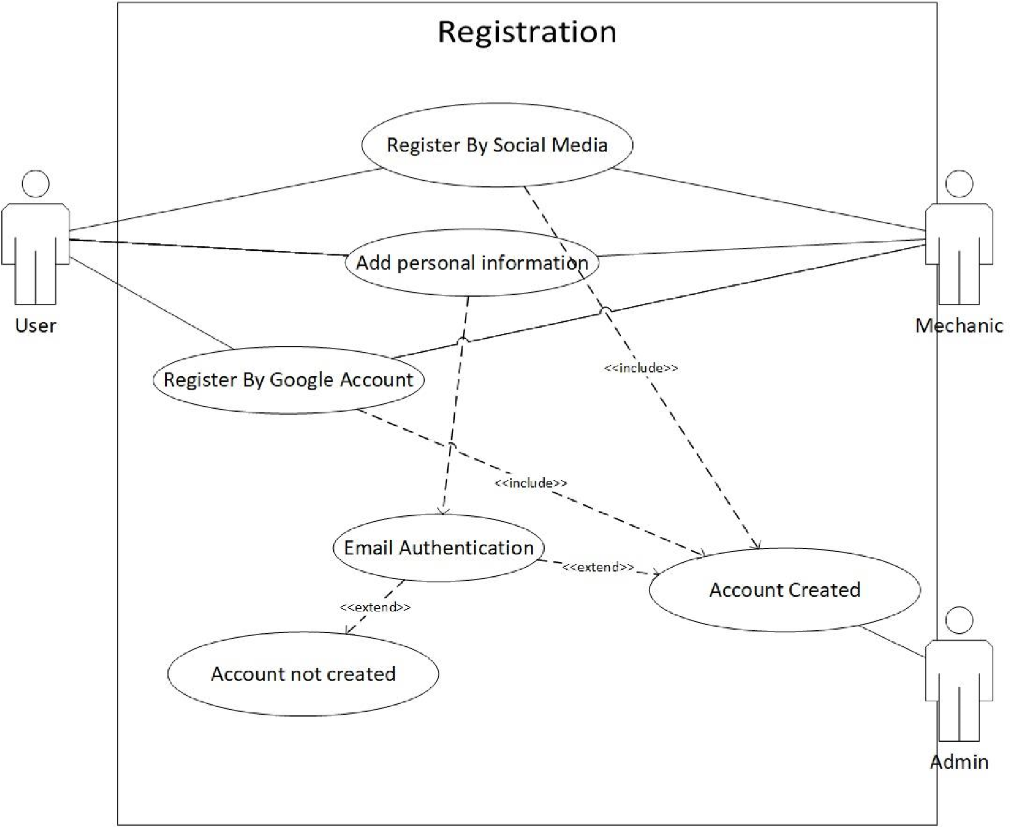

### Login

Figure 2:Use Case of Login

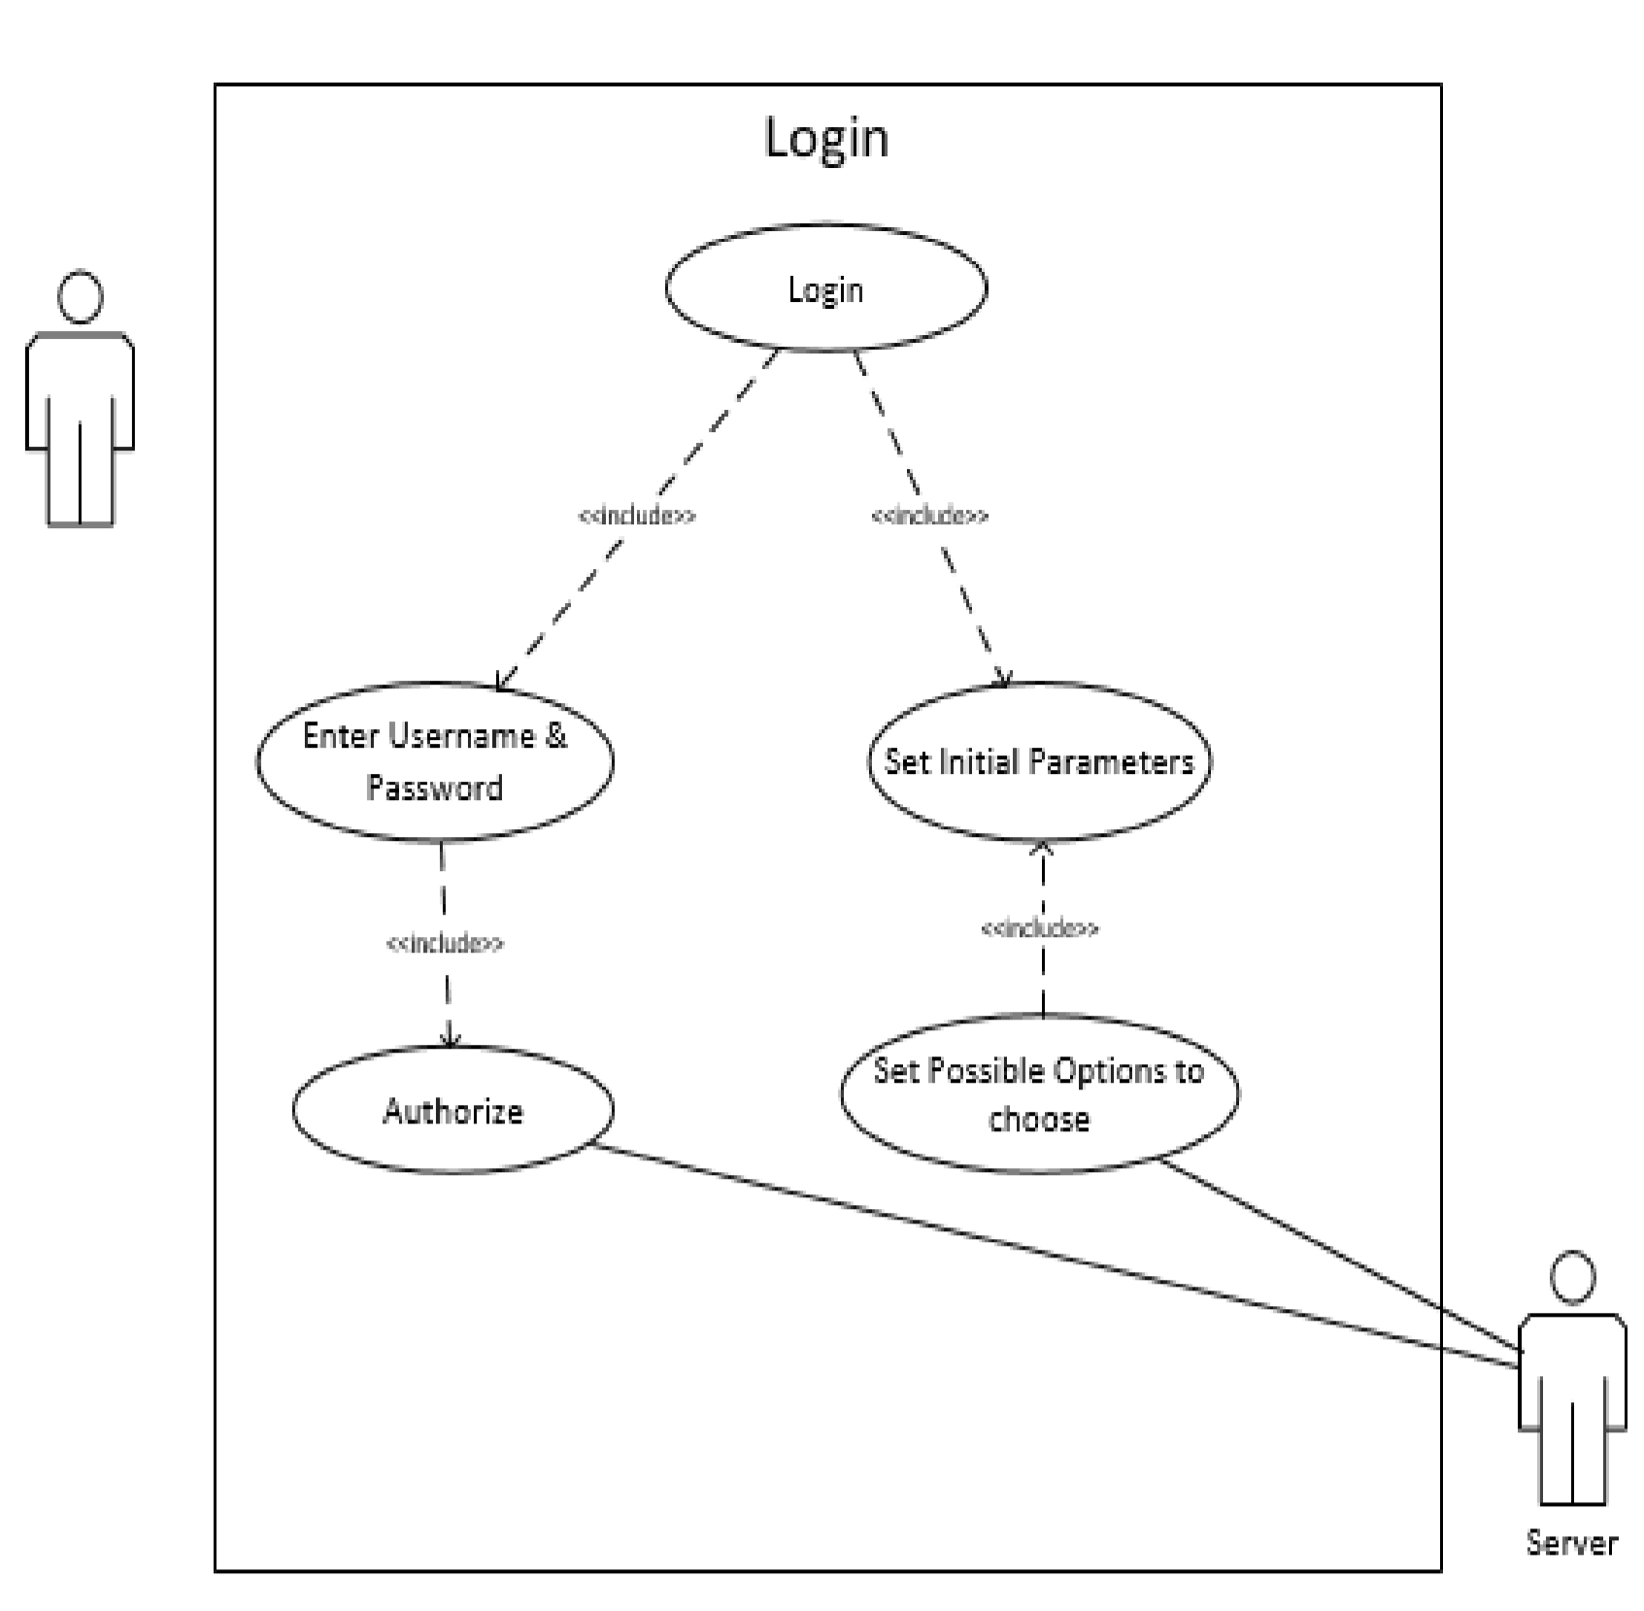

### Search Mechanic

Figure 3:Use Case of Search Mechanic

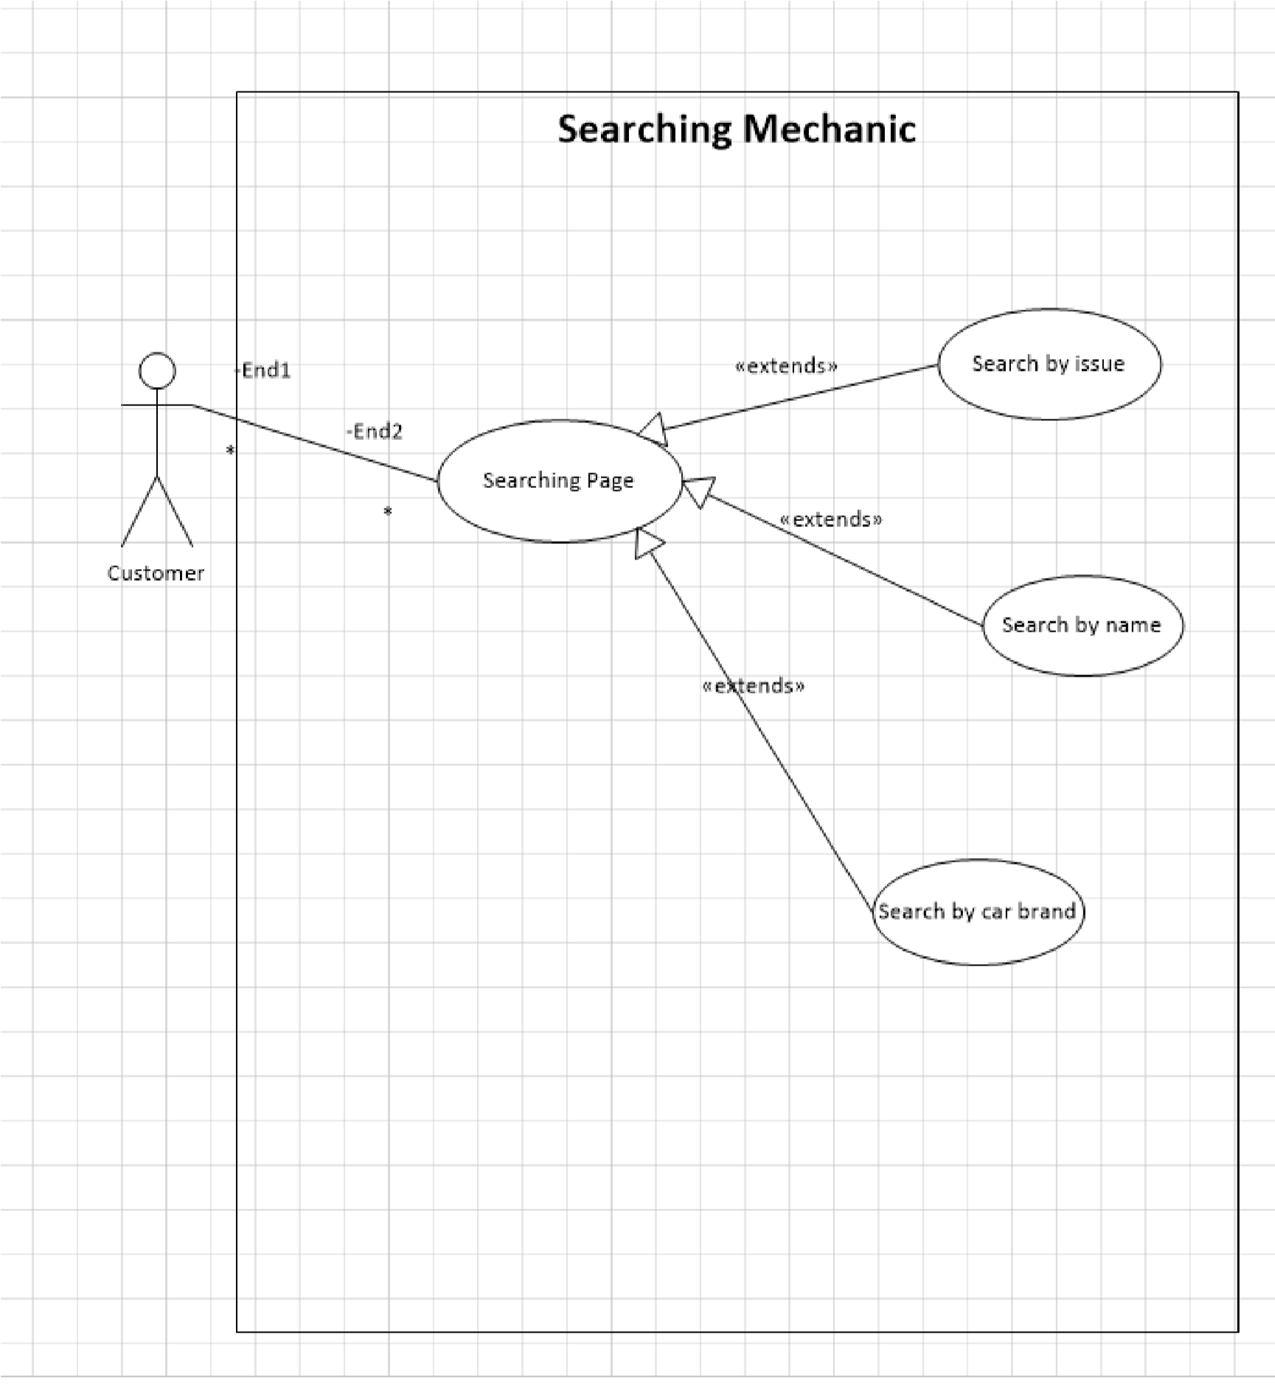

### Book Mechanic

Figure 4:Use Case of Book Mechanic

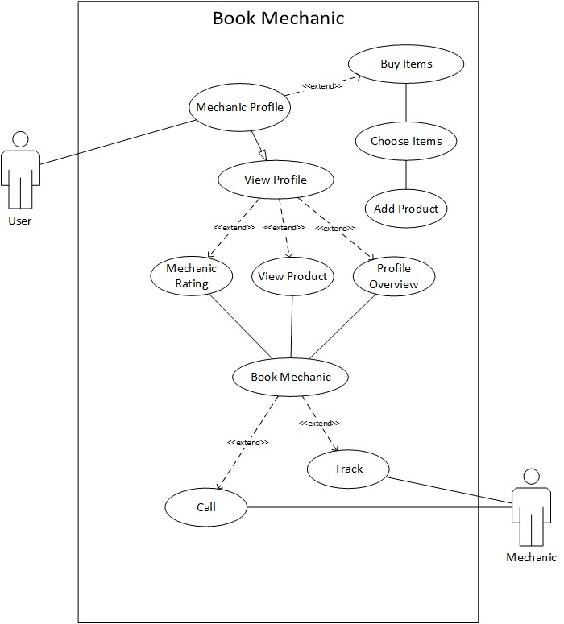

### Mechanic Review and Rating

Figure 5:Use Case of Mechanic Review & Rating

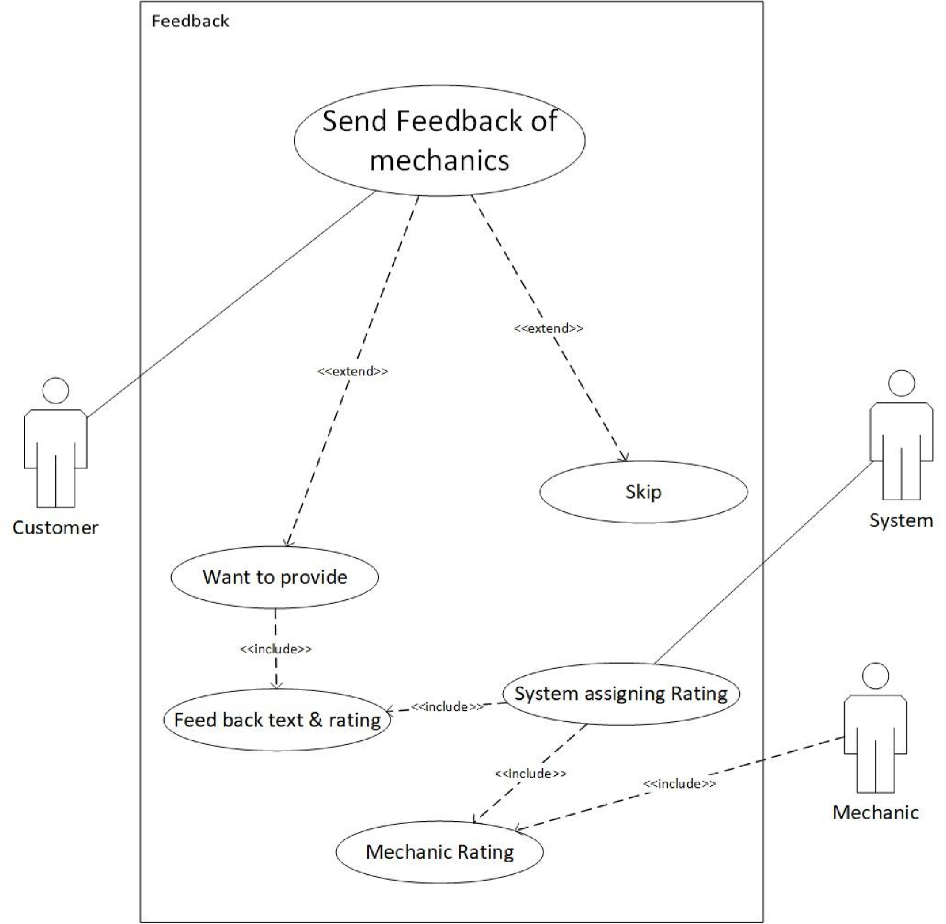

### Chat Box

Figure 6:Use Case of Chat Box

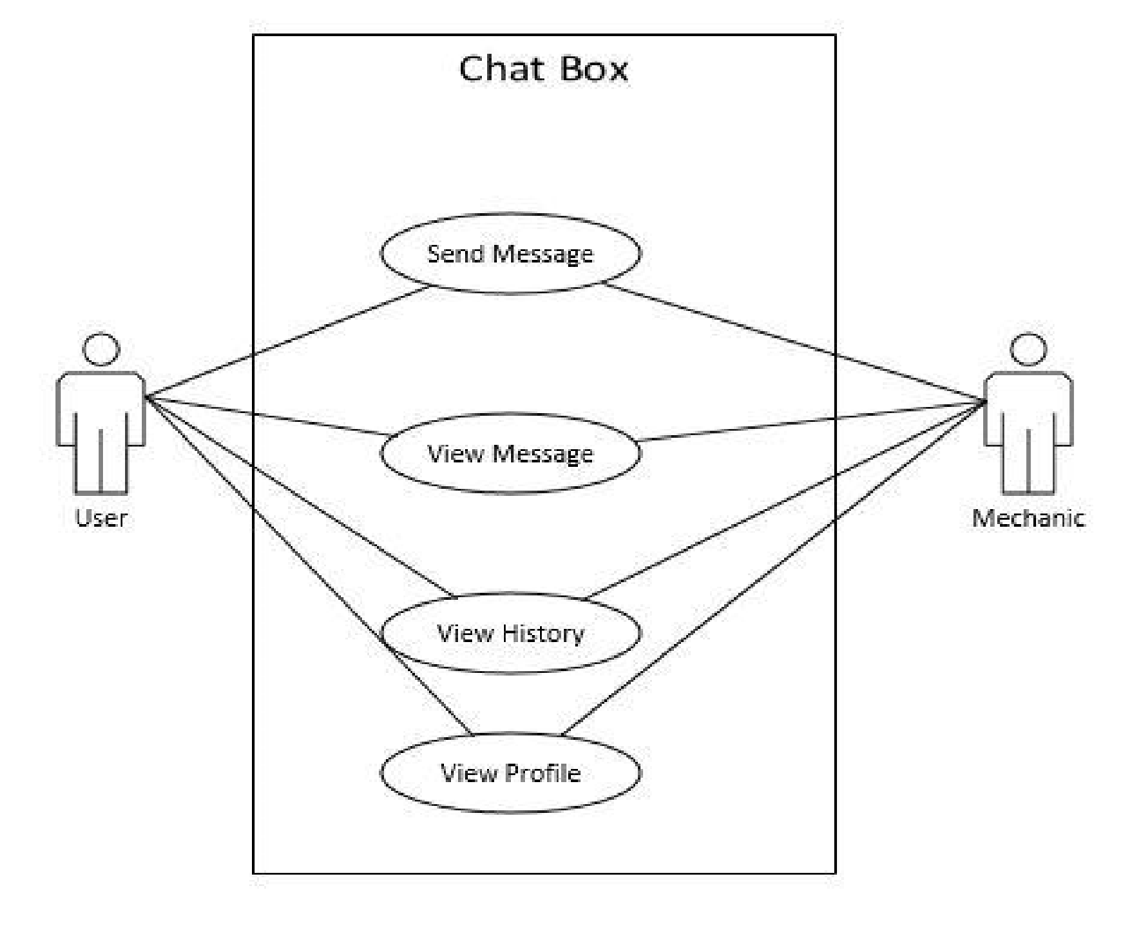

### Post Vehicle Issue

Figure 7:Use Case of Post Vehicle Issue

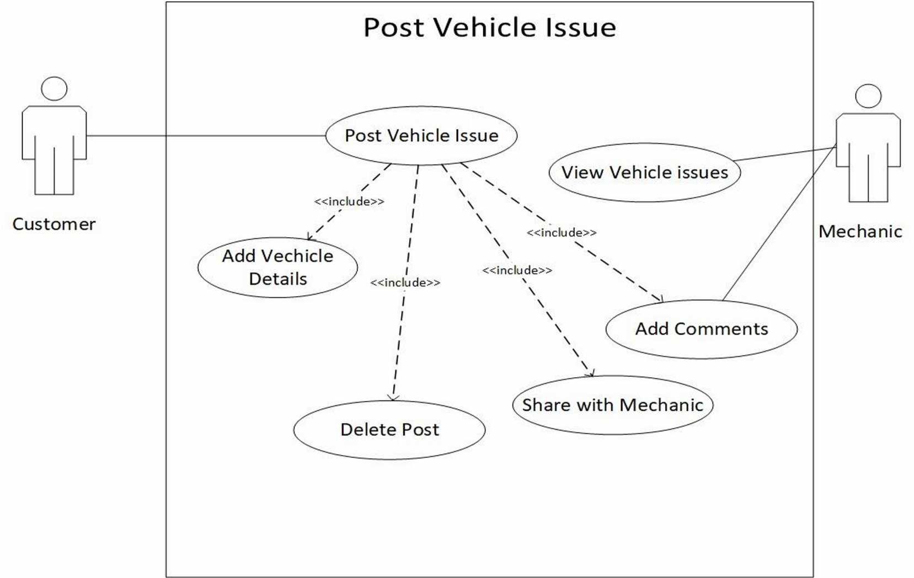

### Edit Profile

Figure 8: Use Case of Edit Profile

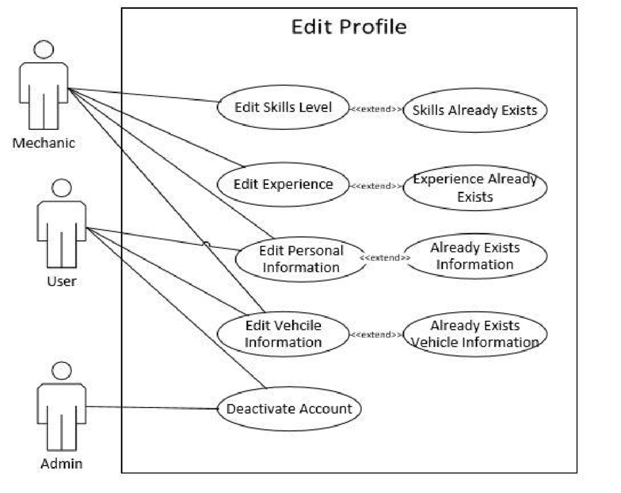

## Design Constraints

These are conditions that need to happen in order for a project to be successful. This can be categorized into Standards compliance, Hardware limitations and so on.

### Standards Compliance

This determines requirements for the system, which are in compliance with the specified standards.

Developers shall implement unit testing at any stage of development to ensure that the site is bug free hence reduce the effects that could occur such as site – breakdown.

### Hardware limitations

This implies when the software can operate on existing hardware or some predetermined hardware.

The design team is expected to build the restful API using Laravel PHP Framework along with the VueJS as the front-end.

## Logical database requirements

### File Format

The system must store all the user account information as well as the sessional grade records. All the data shall be stored in text-based flat files. For each user account, the login ID, name, password, age, email address, phone among others shall be stored in one file. The email address gives the user option to receive any further information or update about the software. Each attribute shall be delimited by a semicolon, and all the entries shall be sorted alphabetically by the login ID. Furthermore, for each user account, there shall be a grade report file which contains every sessional grade result for a certain user. A grade report file shall contain the following attributes: session ID, date (dd/mm/yyyy), duration (minutes), number of pauses, and number of correct timings. Each entry shall also be delimited by a semicolon and sorted alphabetically by the session ID.

Figure 9: Database Diagram

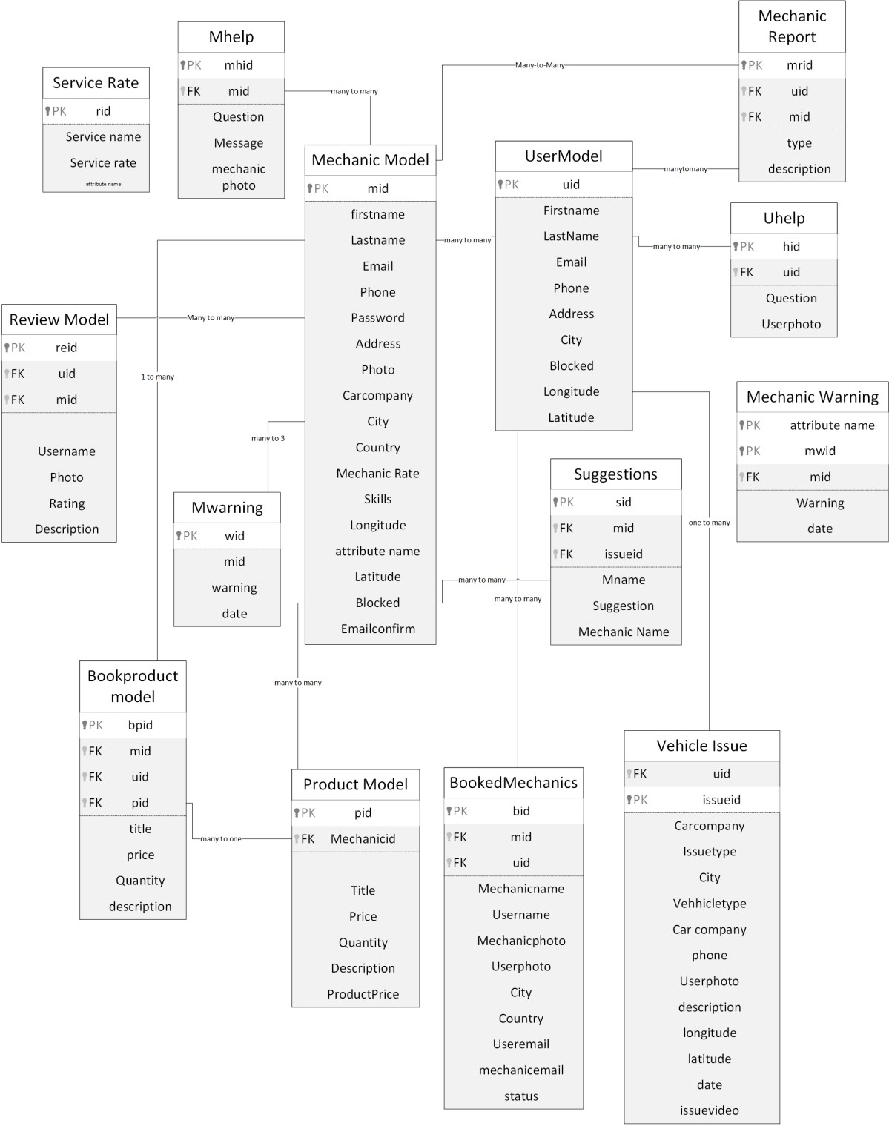

# Change management process

Any requests to change the project scope and requirements shall be discussed by all the members of the team . A change will be made only when the majority of the team agree on the change. In this case, the SRS document shall be updated by the team members in order to reflect the changes, and a date of change shall be noted in the file. If this change request is made by the anyone outside of the team, that is the project supervisor, we will have to contact the team supervisor, Dr. Kasawuli Rashidah () via email. If a change request is made by a team member, he or she can raise it during the weekly team meeting or contact other team members via email.

# Document Approval

By signing this document, I approve the content of this SRS document.

**Supervisor:**

Name (printed): Dr. Kasawuli Rashidah

Signature:

Date:

# Supporting Information

## Outline of Section 3.1